Instructions - Consult On-line system:

1. Click on the sign In eRaider button. Image 1

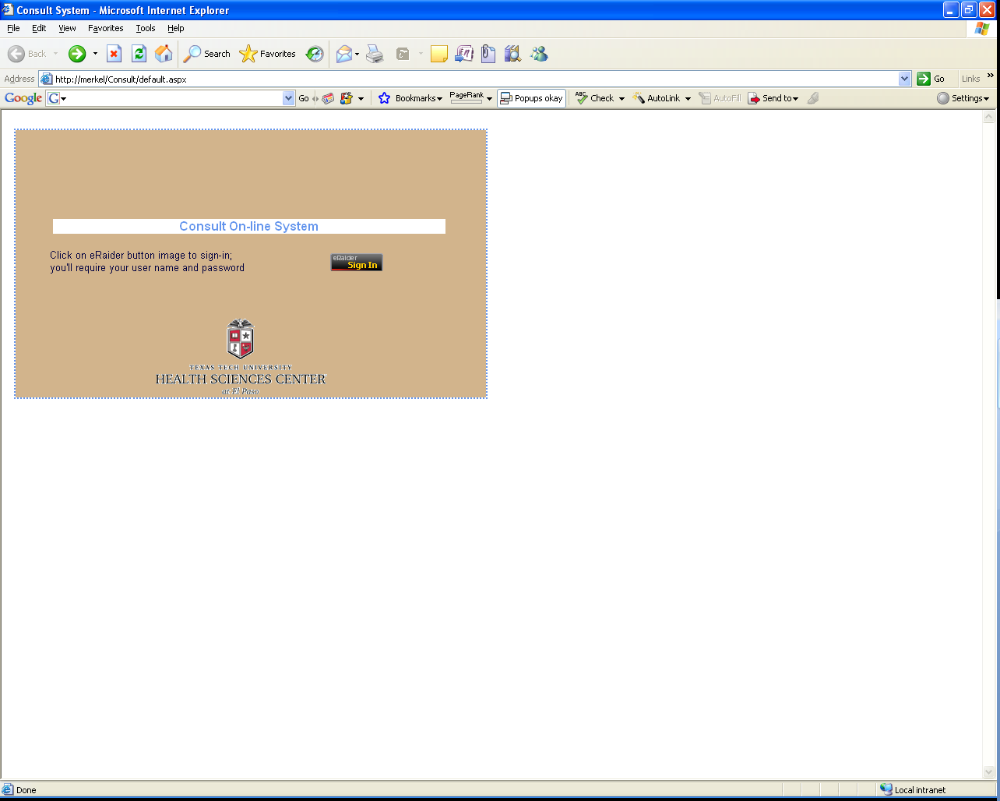

Image 1

2. Enter your eRaider credentials and click Sign In. Image 2

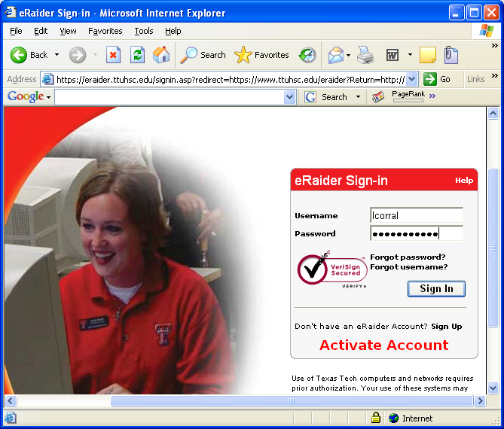

Image 2

3. Consult On-line System main menu. Image 3

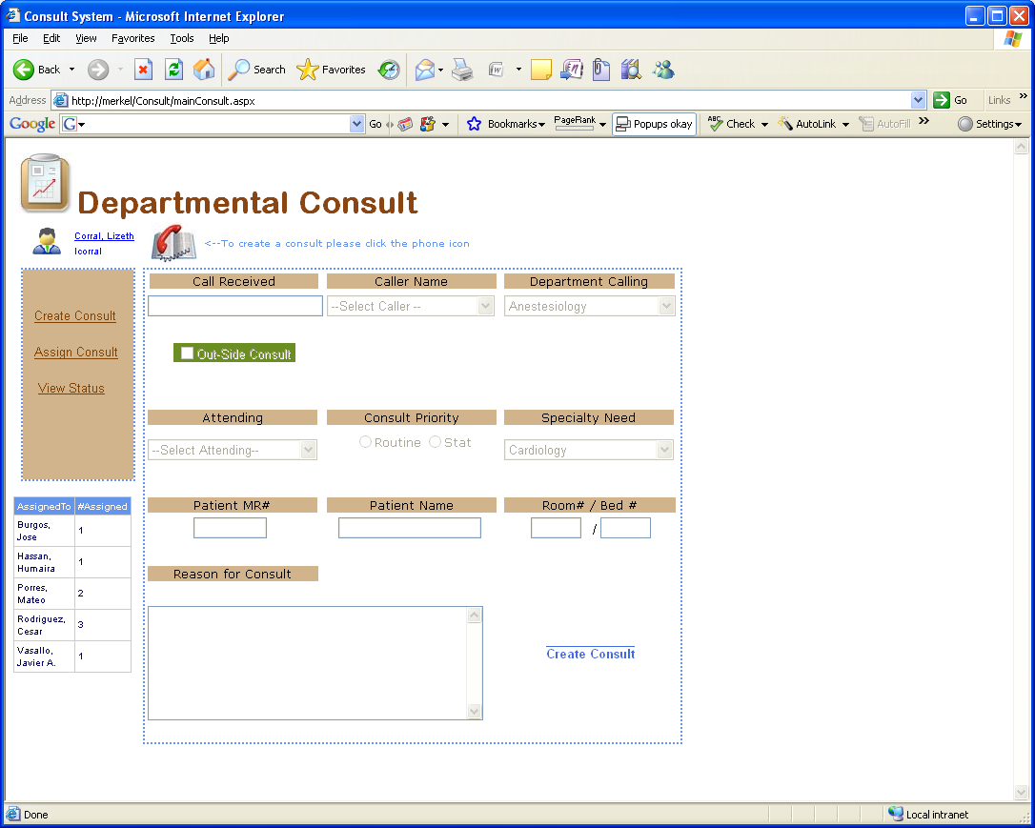
-To create a consult, click the Phone icon.
-Fill up all the consult details
-Click Create Consult

Summary of number of consults assigned

Image 3

4. Once the Consult has been created, please click the “assign consult” link and click the assign button . Image 4

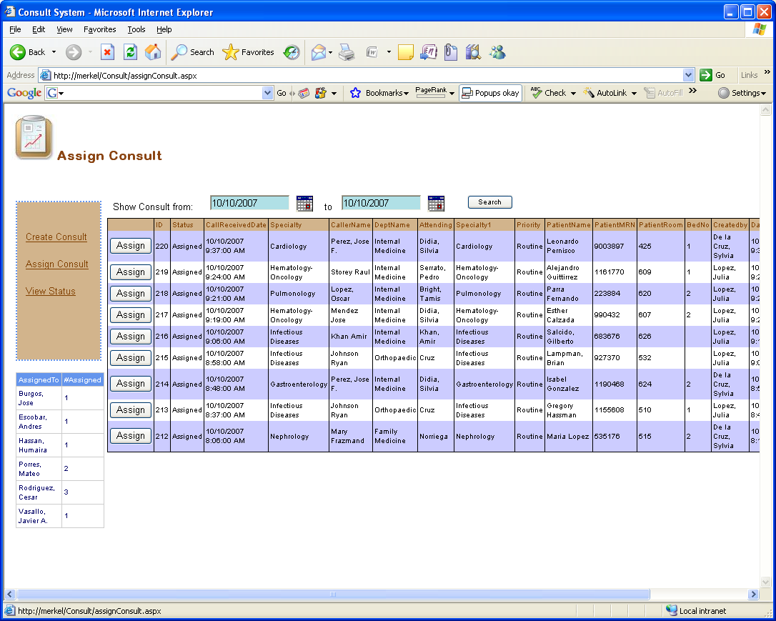

Image 4

5. Assign Consult from the drop down list, first select if is a resident or a faculty.
Click assign, and email will be sent to the assigned resident/faculty Image 5

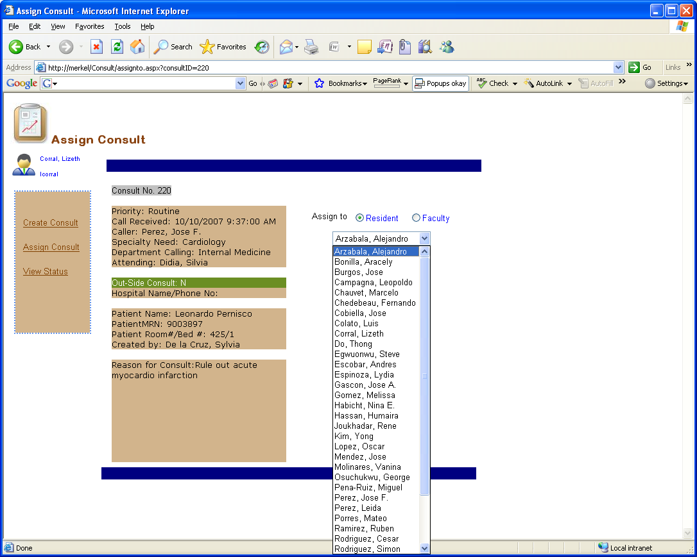

Image 5

